PROJECT REPORT TEMPLATE

BUILD A EMPLOYEE TRAVEL APPROVAL

APPLICATION FOR CORPORATES

1.INTRODUCTION

1.1 Overview

Corporate travel fosters idea sharing and economic growth. One of the primary purposes of business travel is to share knowledge and ideas. Corporates travel management is a company structure to facilitate business travel. This includes planning a business trip, organizing a corporate event, or any other necessary task for the corporate traveller. Ensuring the process is handled properly and according to compliance is the job of corporate travel agent.

The objective of the Company travel policy is to lay down guidance which are to be followed by an employee on domestic or international travel for official work and also to ensure that the travel for official work and also to ensure that the travel of employees is effictievely managed.

1.2 Purpose

The main objective of pre-trip approval is to control undesirable travel buying behaviours of employees and cost. The approver verifies the travel request according to the travel policy of the corporate and decides to approve or decline.

Corporate travel management addresses all functions associated with supporting business travel for employees, customers, vendors and business partners.

Problem Definition & Design Thinking

2.1 Empathy Map

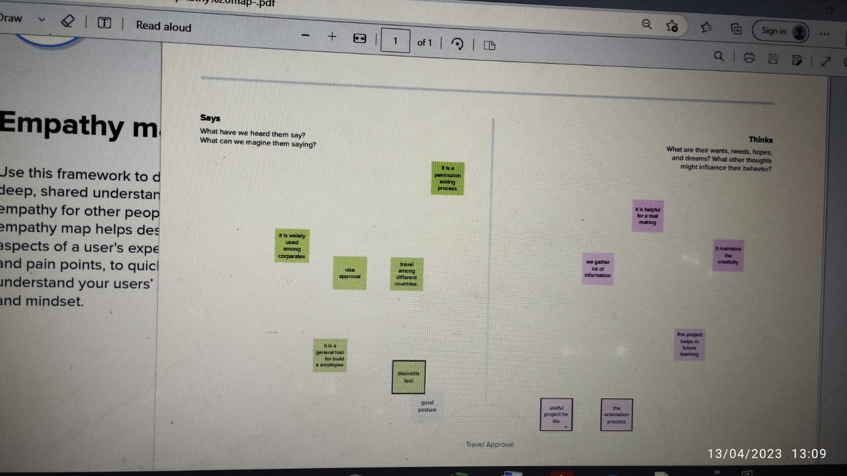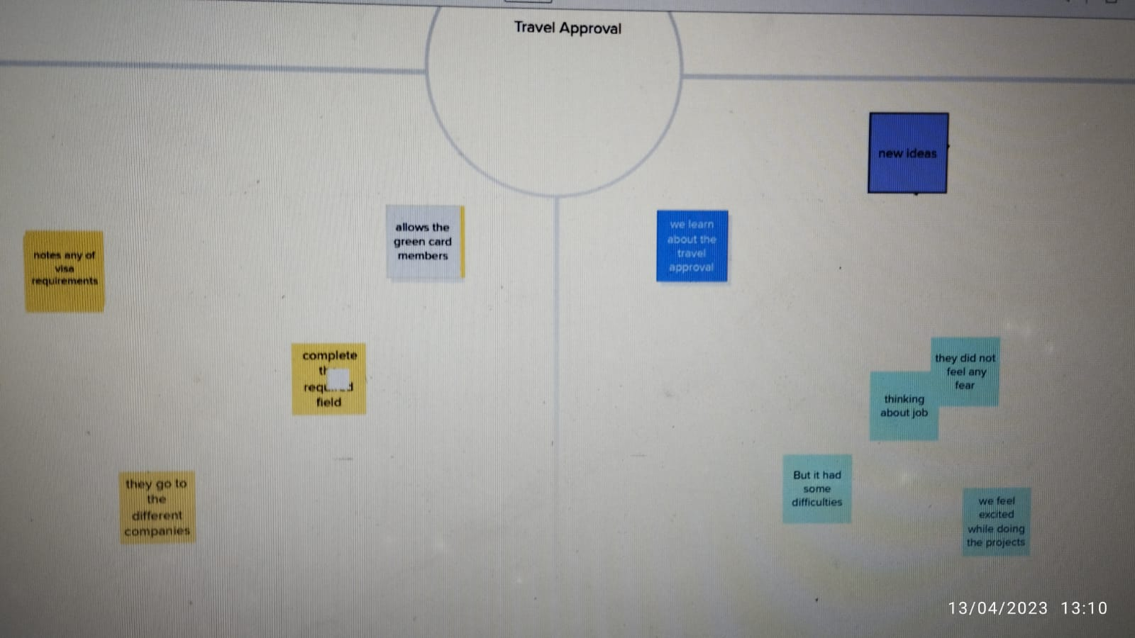

2.2 Ideation & Brainstorming Map

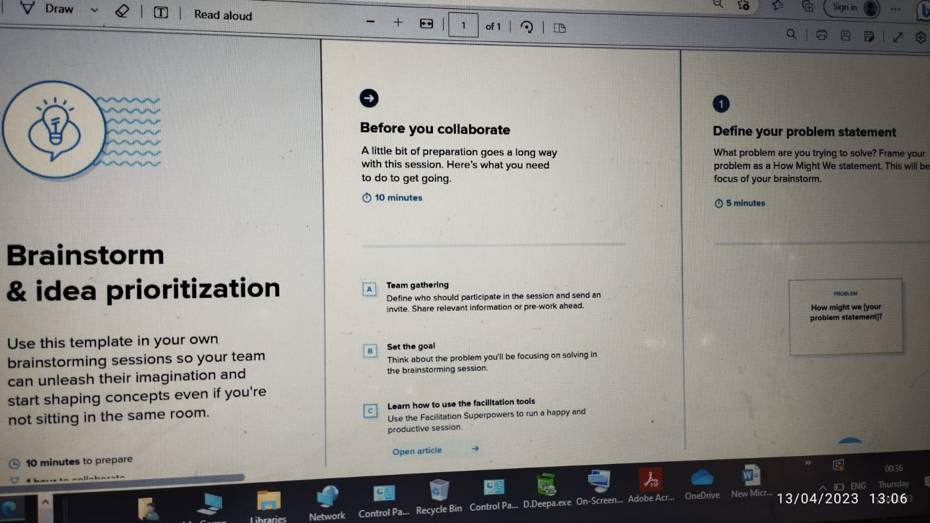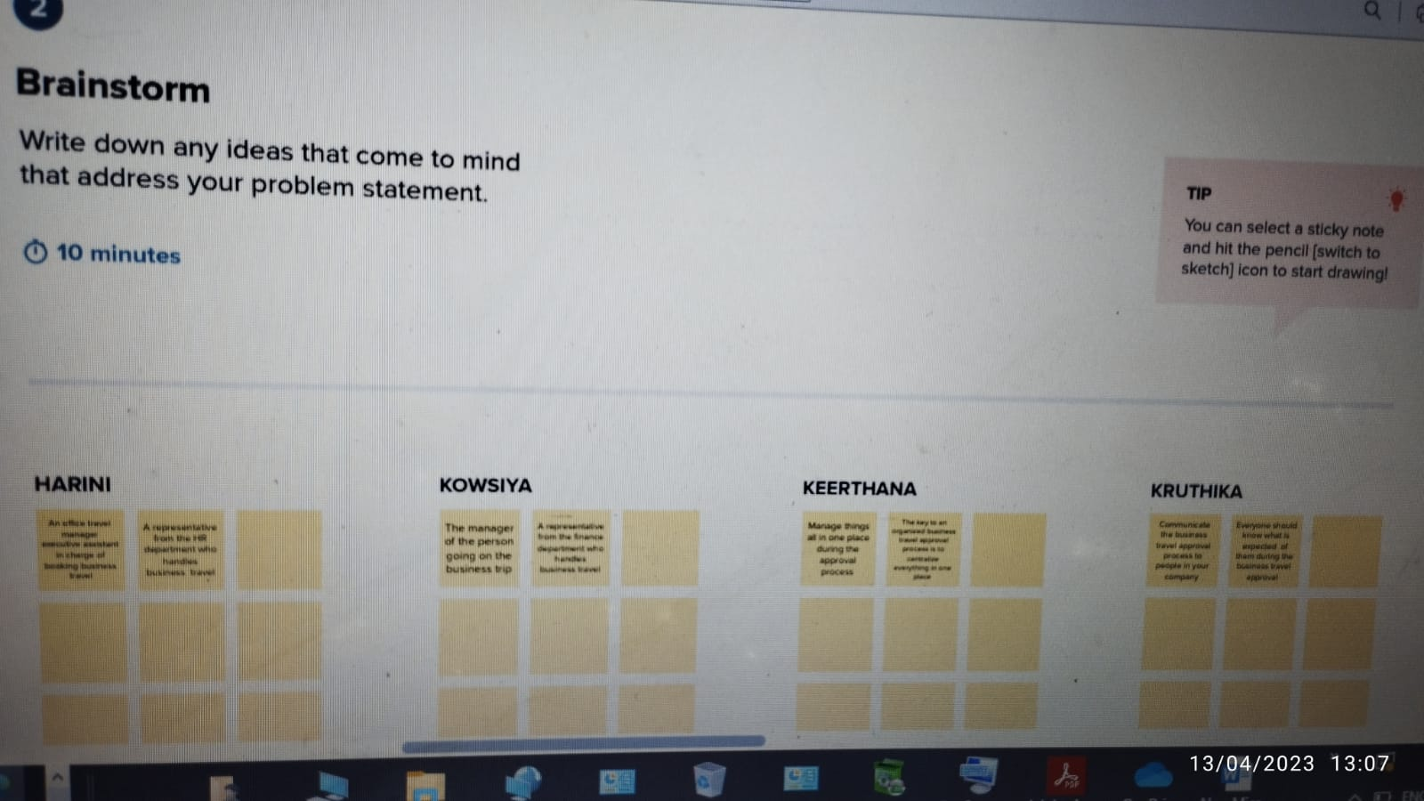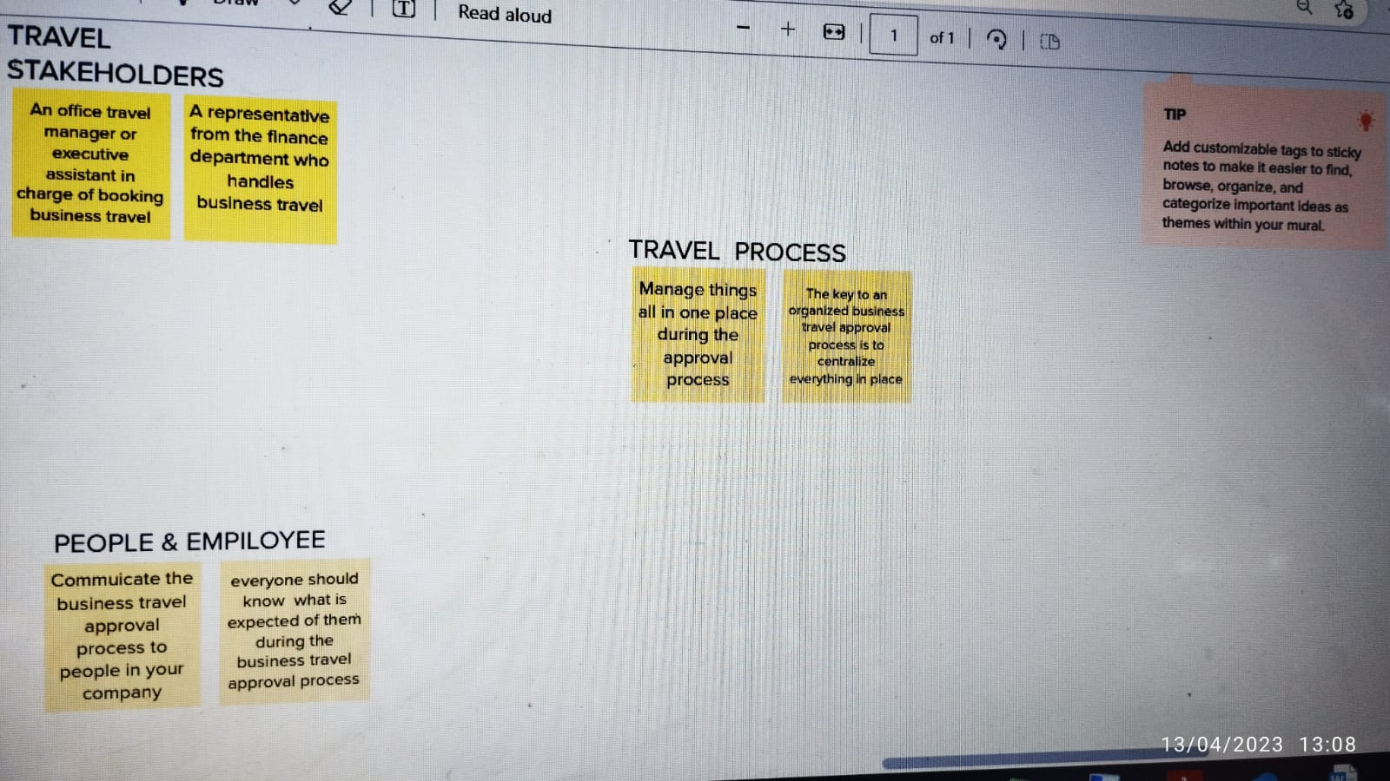

RESULT

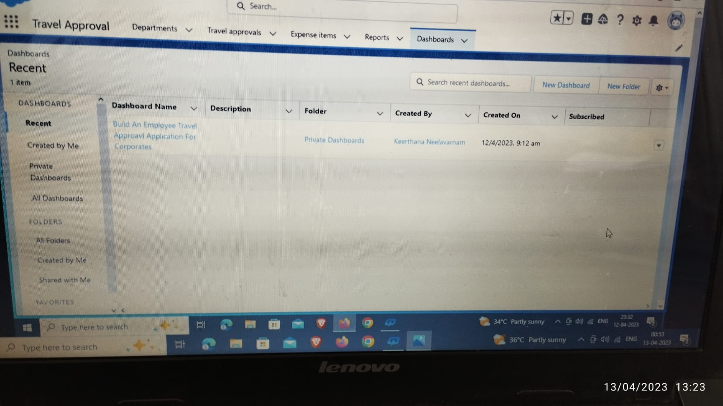

Travelling is an essential part of education. It increases our knowledge and widens our intellect. During travelling, a traveler visits different places and comes in to talk with public in different regions, their traditions, cultures and ways of life. Thus, it provides the traveler with the firsthand knowledge.

ADVANTAGES AND DISADVANTAGES

Advantages of Travel approval

• Efficiency.

• Expertise.

• Cost Savings Benefits of Corporate Travel.

• Corporate travel time saving.

• 24/7 Business Travel support.

• Analytics for corporate travel.

• Technology as a benefit of corporate travel.

Disadvantages of travel approval

• Exploitation of local culture.

• Tourist lack of compliance.

• Lack of job security or seasonal only.

• Limited to service only jobs.

• Uneven infrastructure development.

• Foreign business owners.

• Disregard for other sectors.

APPLICATIONS

• About the sample application.

• Installing the sample application.

• Defining the use as an external web browser.

• Entering the travel request with flight and hotel information.

• Approving the travel request.

CONCLUSION

Many people are not privileged enough to do that. Those who do get the Chance, it brings excitement in their lives and teaches them new things. No matter how a travelling experience may go, whether good or bad, it will definitely help you learn.

FUTURE SCOPE

The scope of performance management is almost as broad as its root, human resources management. A performance management system has to conform to the overall organizational structure. It should not be viewed in isolation, but rather as underlying the entire organization. This ensures the fundamental aim of performance management system, to ensure good work from every department in the organization.

APPENDIX

